Skewness
Skewness is a statistical measure that quantifies the asymmetry of a probability distribution around its mean. It indicates whether the data is more heavily concentrated on one side of the average, which helps identify outliers and determine the most appropriate statistical methods for analysis

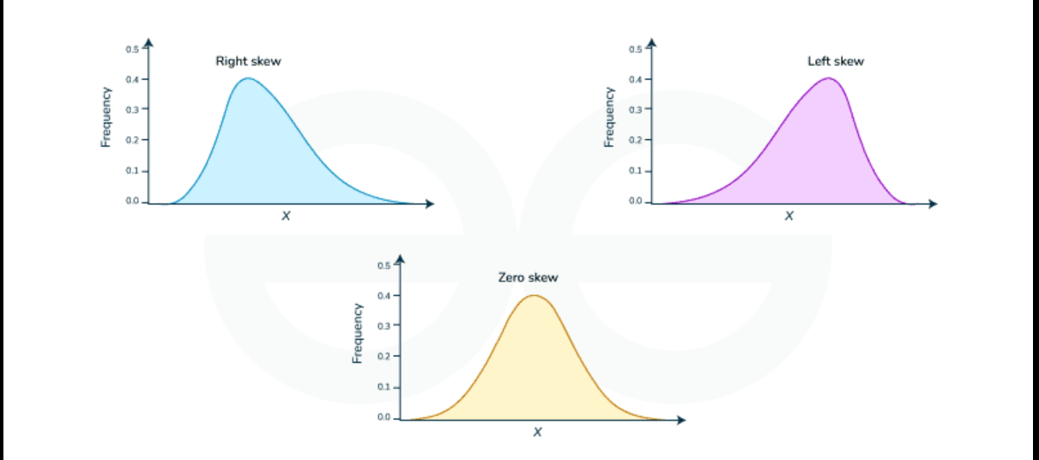

Positive Skew (Right Skew): The right tail is longer. The mean is greater than the median, and the median is typically greater than the mode. This often occurs with data bounded at zero (e.g., income or housing prices), where a few high outliers pull the average up.
Negative Skew (Left Skew): The left tail is longer. The mean is less than the median, and the median is less than the mode. This often happens in testing scenarios where most students score very high, but a few low scores drag the average down

1. Normal (Gaussian) Distribution
- Definition: A continuous, symmetric, bell-shaped distribution where most data clusters around the central mean
- ML Use Case: Used in Linear Regression and Logistic Regression, which assume that residuals (errors) are normally distributed. It is also the foundation of Gaussian Naive Bayes classifiers and Standardization (Z-score scaling).

2. Uniform Distribution
- Definition: A distribution where all outcomes within a specific range have an equal probability of occurring
- ML Use Case: Used during Weight Initialization in Deep Learning (e.g., Xavier/Glorot Uniform Initialization) to prevent vanishing gradients. It is also used to define boundaries in Hyperparameter Tuning random searches.

3. Binomial Distribution
- Definition: A discrete distribution representing the number of successes in a fixed number of independent "Yes/No" trials.
- ML Use Case: Used to model performance in Binary Classification problems (e.g., predicting click-through rate, churn, or fraud) and calculating confidence intervals during A/B Testing evaluations.

4. Poisson Distribution
- Definition: A discrete distribution counting how many times an independent event occurs within a fixed interval of time or space
- ML Use Case: Used as the loss function in Poisson Regression (a type of Generalized Linear Model) to predict count-based targets, such as website traffic spikes, call center volumes, or daily hospital admissions.

5. Exponential Distribution
- Definition: A continuous, right-skewed distribution describing the time or distance between independent Poisson events occurring at a constant rate.
- ML Use Case: Used in Survival Analysis models to predict machine failure times (predictive maintenance) or customer time-to-churn. It is also applied in Anomaly Detection to find unusually long wait times.

Hypothesis
In statistics, a hypothesis is an unproven claim or assumption about a population parameter that you test using data. Testing always involves two opposing hypotheses:
- Null Hypothesis: The status quo assumption. It states that there is no effect, no change, or no difference. (e.g., "This new medicine works exactly the same as the old sugar pill").
- Alternative Hypothesis : The claim you want to prove. It states that there is an effect, a change, or a significant difference. (e.g., "This new medicine is more effective than the sugar pill").

P-Value
The p-value (probability value) is a number between 0 and 1 that tells you how compatible your sample data is with the Null Hypothesis
- Definition: It is the probability of obtaining test results at least as extreme as the observed results, assuming that the null hypothesis is completely true.
- The Goal: It measures surprise. A tiny p-value means your data is highly surprising if Ho is true, suggesting Ho is likely false.

T- test

A t-test is a statistical method used to determine if there is a significant difference between the means (averages) of two groups, helping you decide if that difference is real or just random noise.
It answers questions like: "Do users spend more time on App Layout A than App Layout B?" or "Does a class of students score higher after using a new study guide?"

Types of T-Tests
- Independent (Two-Sample) T-Test: Compares the means of two completely different groups (e.g., Treatment vs. Control group in an A/B test).
- Paired T-Test: Compares the means of the same group at two different times (e.g., Weights of participants before and after a diet plan).
- One-Sample T-Test: Compares the mean of one group against a known standard (e.g., Checking if a factory's potato chip bags actually weigh the advertised 50 grams).

